Clustering Algorithms
What is clustering?
Clustering is a Machine Learning algorithm and a popular technique for classifying data. It falls under the category of unsupervised machine learning algorithms as it’s useful in dealing with unlabeled and unstructured data.

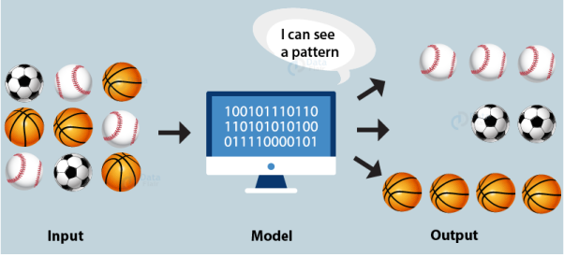

Clustering is a great way to start making sense out of unstructured data.

In this algorithm we usually deal with only features within data and do not have any target labels or classes. These algorithms discover hidden patterns or data groupings without the need for human intervention. Its ability to discover similarities and differences in information make it the ideal solution for exploratory data analysis.
In other words, Clustering is a data mining technique which classifies datasets based on their similarities or differences. This will process raw data and unclassified data objects into groups represented by structures or patterns in the information. Clustering algorithms can be categorized into a few types, specifically exclusive, overlapping, hierarchical, and probabilistic.
Why Clustering?
To group items that might have same attributes together. It might be helpful to imagine that you have millions of chemical compounds that you cannot see and judge what they are trying to tell, what is similar among them. By clustering you will group those millions of clusters in let’s say 5 or 10 clusters based on some similarity among them making it easier for you to analyze those 5 or 10 clusters rather than seeing each compound individually.
Clustering Applications
Clustering has a wide range of applications in diverse areas such as:
- Market research and customer segmentation: Identify customer groups based on purchasing patterns and preferences for targeted marketing and personalized service offerings.
- Social network analysis: Detecting communities and understanding social dynamics.
- Biological data analysis: Grouping genes or proteins with similar functionalities.
- Finance: Grouping stocks into sectors based on various financial metrics and market behaviors.
- Urban planning: Clustering helps in urban planning by grouping areas with similar land use or demographic characteristics.
- Information retrieval: Grouping similar documents to facilitate efficient retrieval of relevant information based on user queries or interests.
- Web search: Search engines use clustering to group similar results, enhancing user experience by providing categorized information.
- Image segmentation: Segmenting images into meaningful clusters, such as separating objects from the background or identifying similar features in images.
- Recommender systems: Recommending products or content by grouping similar users based on their preferences or past behavior.
- Anomaly detection: Clustering can be used to detect unusual patterns or anomalies in areas such as fraud detection and network monitoring.
Types of Clustering
We can categorize data under various rules and parameters. From simple similarities in data values to comparing relationships between data points, there are a multitude of ways to go about the problem. One way to categorize all the techniques is in the format below.
- Partition based Clustering
- Hierarchical Clustering
- Density-based Clustering
We’ll briefly explain these before moving on to applications.
Partition Based Clustering
Given a database of n objects or data tuples, a partitioning method constructs k partitions of the data, where each partition represents a cluster.
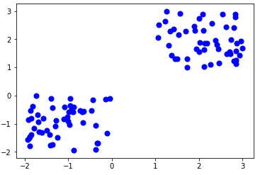
This clustering method classifies the information into multiple groups based on the characteristics and similarity of the data. It’s the data analysts job to specify the number of clusters that has to be generated for the clustering methods.
In the partitioning method when database(D) that contains multiple(N) objects then the partitioning method constructs user-specified(K) partitions of the data in which each partition represents a cluster and a particular region.
Hierarchical Clustering
Hierarchical clustering, also known as hierarchical cluster analysis, is an algorithm that groups similar objects into groups called clusters. The endpoint is a set of clusters, where each cluster is distinct from each other cluster, and the objects within each cluster are broadly similar to each other.
Hierarchical clustering starts by treating each observation as a separate cluster. Then, it repeatedly executes the following two steps: (1) identify the two clusters that are closest together, and (2) merge the two most similar clusters. This iterative process continues until all the clusters are merged together.
Hierarchical Clustering bridges the gap made by k means clustering, it takes away the problem of having to pre define the number of clusters at the beginning of the model. Hierarchical clustering, as the name suggest is an algorithm that builds hierarchy of clusters. There are mainly two types of Hierarchical clustering:
Agglomerative Clustering begins with each data point as a separate cluster and at each iteration we merge the closest pair of clusters and repeat this step until only a single cluster is left. Basically it uses a bottom-up approach. In hierarchical clustering we have concept called as proximity matrix which stores the distance between each points. There are multiple distance metrics which can be used for deciding the closeness of two clusters.
- Euclidean distance: distance((x, y), (a, b)) = √(x — a)² + (y — b)²
- Manhattan Distance: distance (x1, y1) and (x2, y2) =
|x1 — x2| + |y1 — y2|
Divisive Clustering or the top bottom approach works in the opposite way. Instead of starting with n clusters ( in case of n observations), it starts with a single cluster and assign all the points to that cluster. Therefore, it doesn’t matter if we have 10 0r 1000 data points, all these data points will belong to the same cluster at the beginning. Now at each iteration, we split the farthest point in the cluster and repeat the process until each cluster contains only a single data point.
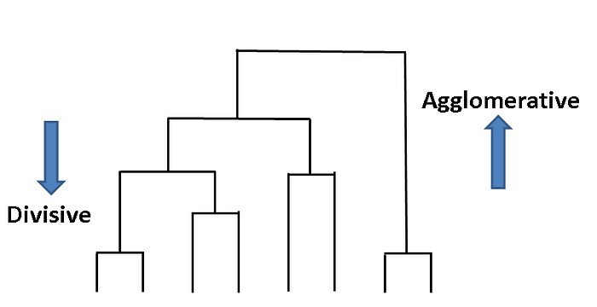
The above image shows both type of hierarchical clustering
Dendrogram is another concept in hierarchical clustering, it is a tree like diagram that records the sequences of merges or splits. Whenever two clusters or data points are merged, we will join them in the dendrogram and the height of the join will be the distance between these points. Now, we can set a threshold distance and draw a horizontal line, the number of cluster will be the number of vertical lines which are being intersected by the line drawn using threshold.
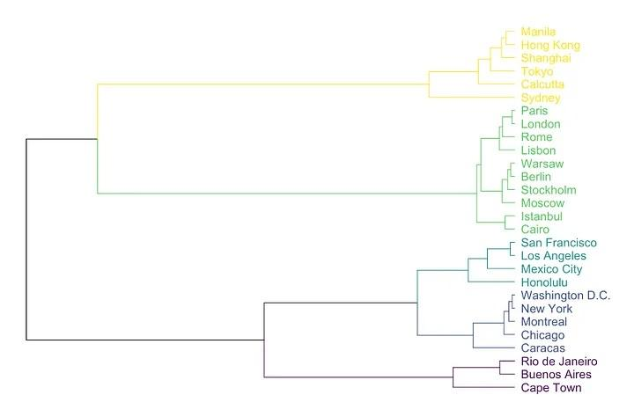
Density-based Clustering
Density-based spatial clustering of applications with noise (DBSCAN) is a well-known data clustering algorithm that is commonly used in data mining and machine learning. DBSCAN groups together points that are close to each other based on a distance measurement (usually Euclidean distance) and a minimum number of points. It also marks as outliers the points that are in low-density regions.
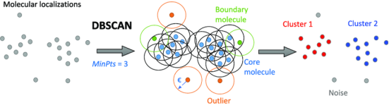

1. Partitioning Clustering: Partitioning Clustering is a type of clustering technique, that divides the data set into a set number of groups. [For Example, the Value of K in KNN and it will be decided before we train the model]. It can be also called as a centroid based method. In this approach cluster center [centroid] is formed such that the distance of data points in that cluster is minimum when calculated with other cluster centroids. A most popular example of this algorithm is the KNN algorithm. This is how a partitioning clustering algorithm looks like

2. Hierarchical Clustering: Hierarchical Clustering is a type of clustering technique, that divides that data set into a number of clusters, where the user doesn’t specify the number of clusters to be generated before training the model. This type of clustering technique is also known as connectivity-based methods. In this method, simple partitioning of the data set will not be done, whereas it provides us with the hierarchy of the clusters that merge with each other after a certain distance. After the hierarchical clustering is done on the dataset the result will be a tree-based representation of data points [Dendogram], which are divided into clusters. This is how a hierarchical clustering looks like after training is done

In Partitioning clustering and Hierarchical clustering, one main difference we can notice is in partitioning clustering we will pre-specify the value of how many clusters we want the data set to be divided into and we don’t pre-specify this value in hierarchical clustering.
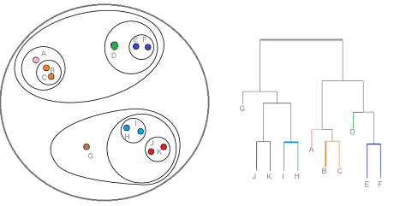
Hierarchical clustering and Dendogram

K-Means Clustering
K-means clustering is a popular unsupervised machine learning algorithm used to group data points into K clusters based on their similarity. The K in K-means represents the number of clusters that the algorithm will create.
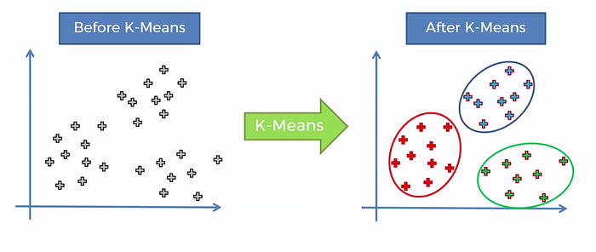
The algorithm starts by selecting K random centroids (points in the feature space) as the initial cluster centers. It then assigns each data point to the nearest centroid based on the Euclidean distance between the data point and the centroid. Next, it computes the mean of each cluster, which becomes the new centroid for that cluster. The algorithm repeats these steps until the centroids no longer change or a maximum number of iterations is reached.
K-means clustering aims to minimize the sum of squared distances between each data point and its assigned centroid. This means that the algorithm is trying to find the cluster centroids that minimize the variance within each cluster and maximize the distance between clusters.
How K-Means Clustering Work?
K-means clustering works by iteratively assigning data points to the nearest cluster centroid, computing the mean of each cluster, and updating the centroids until convergence is reached.

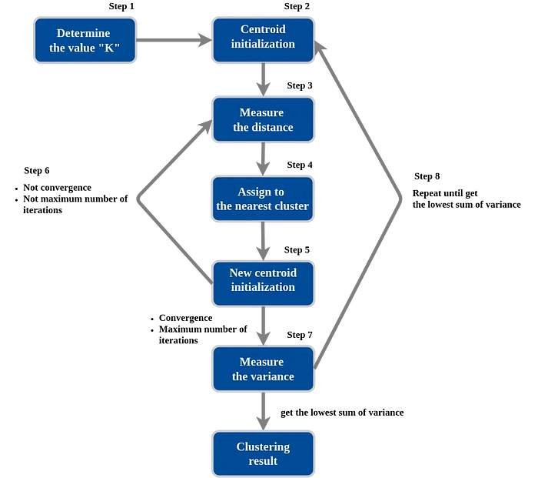

The following steps summarize the K-means clustering process:
- Initialization: Select the number of clusters (K) and randomly initialize K cluster centroids in the feature space.
- Assignment: Assign each data point to the nearest cluster centroid based on the Euclidean distance between the data point and each centroid.
- Update: Compute the mean of each cluster, which becomes the new centroid for that cluster.
- Repeat: Repeat steps 2 and 3 until the centroids no longer change or a maximum number of iterations is reached.
- Convergence: Once convergence is reached, the K clusters represent groups of data points that are similar to each other and dissimilar to data points in other clusters.
Visualization: https://youtu.be/2lZZ_FzlIJY
How Does a Computer Form Clusters?
The way the computer forms clusters is through a process of forming partitions and adjusting the position of cluster heads with well know clustering techniques like K-Means. K-Means is a distance-based clustering technique where K represents the number of clusters to be formed. The goal of the K-Means is to create clusters such that the intra-cluster distance (distance of data inside the cluster) is minimized and that the inter-cluster distance (distance between clusters) is maximized. This is easy to understand with the diagram below. A lot of the computations used to create clusters are from the field of math called Linear Algebra.

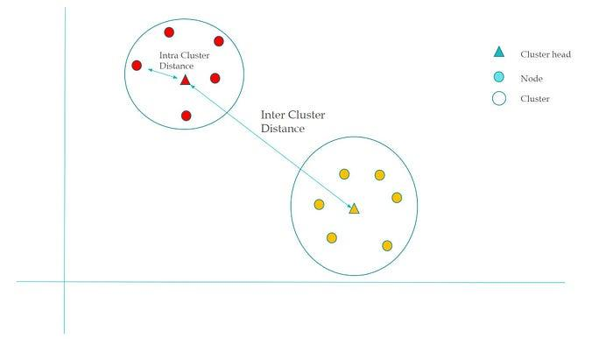
Inter-Cluster Distance vs. Intra-Cluster Distance

Let’s walk through an example of how a computer can perform clusters with K Means where K = 2 clusters. Let’s say a computer is given the raw data about people with their weight and height. As in the picture below, each dot represents a person with the x-axis representing the weight and the y-axis representing the height. We want to group people into two groups of similar weight and height.
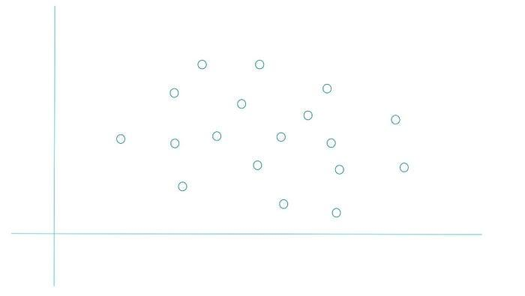
Step 1
The computer’s goal is to create two groups: the red group and the yellow group. The computer will first choose at random two data points to be cluster heads.
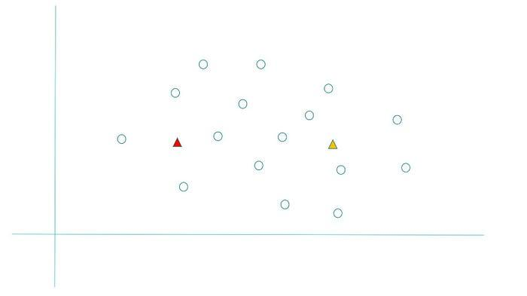
Step 2
Then the computer will form a separation in the data. It does this by finding the line that connects the two cluster heads. Then the computer will create another line (partition) that is perpendicular to the line connecting the two cluster heads. The partition splits the line connecting the two cluster heads perfectly into two.
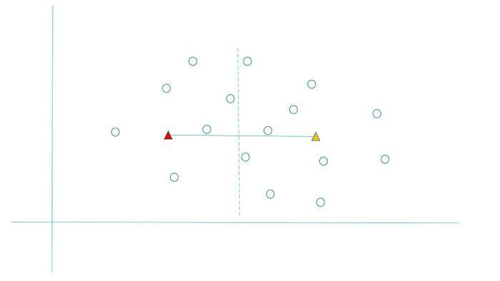
Step 3
Any data point left of the partition line becomes part of the red group and any data point right of the partition line becomes part of the yellow group.
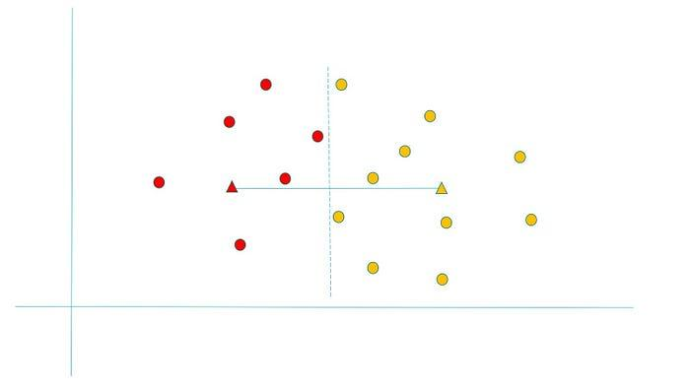
Step 4
Now the computer will readjust the cluster head to be the average of all the points. For example, the red cluster head will move to be the new average of all the red points and the same applies to the yellow.
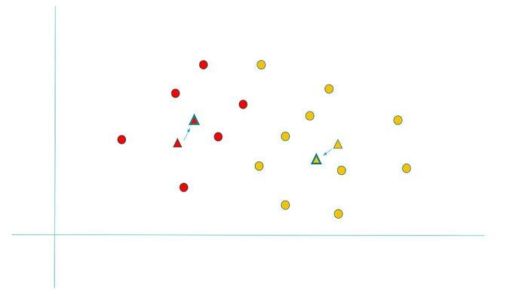
Step 5
Now we are going to repeat step the process and find that a yellow point is left of the partition line.
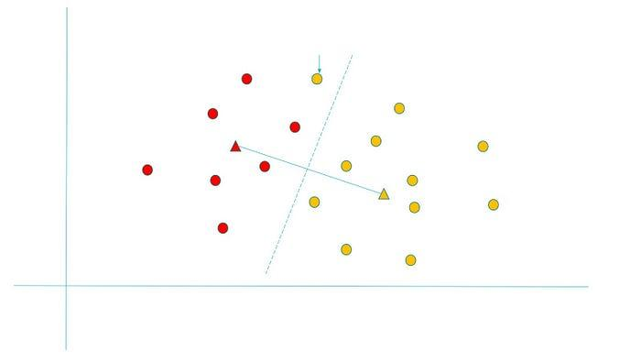
Step 6
This means that this yellow node will become a red point.
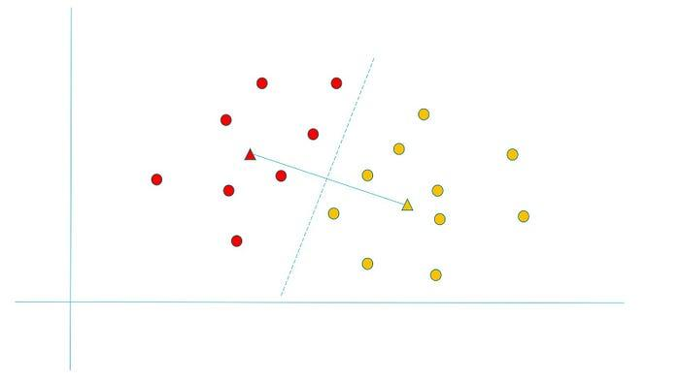
Step 7
Next, we have to readjust the cluster head for each color again to be the average of all the nodes of a given color.
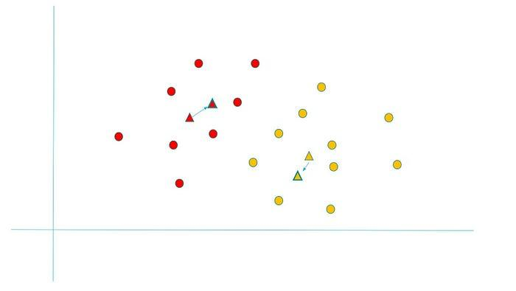

Step 8
Now we repeat the process again and we find that two clusters have been successfully formed with each point belonging to one of the clusters.

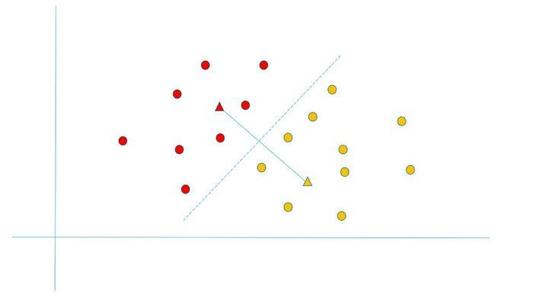
Example of K-means clustering
Cluster the following eight points (with (x, y) representing locations) into three clusters:
A1(2, 10), A2(2, 5), A3(8, 4), A4(5, 8), A5(7, 5), A6(6, 4), A7(1, 2), A8(4, 9).
Initial cluster centers are: A1(2, 10), A4(5, 8) and A7(1, 2).
The distance function between two points a = (x1, y1) and b = (x2, y2) is defined as → Ρ(a, b) = |x2 — x1| + |y2 — y1|
Use K-Means Algorithm to find the three cluster centers after the second iteration.
We follow the above-discussed K-Means Clustering Algorithm:
→ Iteration-01:
- We calculate the distance of each point from each of the centers of the three clusters.
- The distance is calculated by using the given distance function.
The following illustration shows the calculation of the distance between point A1(2, 10) and each of the centers of the three clusters:
Calculating Distance Between A1(2, 10) and C1(2, 10)
Ρ(A1, C1)
= |x2 — x1| + |y2 — y1|
= |2–2| + |10–10|
= 0
Calculating Distance Between A1(2, 10) and C2(5, 8)
Ρ(A1, C2)
= |x2 — x1| + |y2 — y1|
= |5–2| + |8–10|
= 3 + 2
= 5
Calculating Distance Between A1(2, 10) and C3(1, 2)
Ρ(A1, C3)
= |x2 — x1| + |y2 — y1|
= |1–2| + |2–10|
= 1 + 8
= 9
In a similar manner, we calculate the distance of other points from each of the centers of the three clusters.
Next,
- We draw a table showing all the results.
- Using the table, we decide which point belongs to which cluster.
- The given point belongs to that cluster whose center is nearest to it.
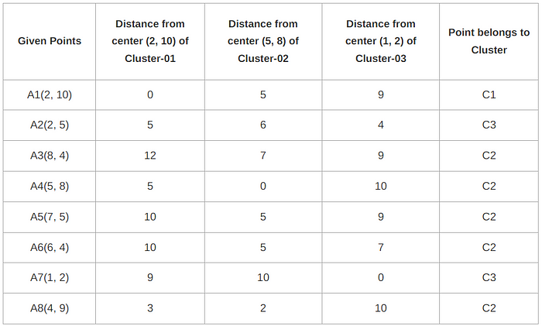
From here, New clusters are-
Cluster-01:
The first cluster contains points-
- A1(2, 10)
Cluster-02:
The second cluster contains points-
- A3(8, 4)
- A4(5, 8)
- A5(7, 5)
- A6(6, 4)
- A8(4, 9)
Cluster-03:
The third cluster contains points-
- A2(2, 5)
- A7(1, 2)
Now,
- We re-compute the new cluster clusters.
- The new cluster center is computed by taking mean of all the points contained in that cluster.
For Cluster-01:
- We have only one point A1(2, 10) in Cluster-01.
- So, the cluster center remains the same.
For Cluster-02:
Center of Cluster-02
= ((8 + 5 + 7 + 6 + 4)/5, (4 + 8 + 5 + 4 + 9)/5)
= (6, 6)
For Cluster-03:
Center of Cluster-03
= ((2 + 1)/2, (5 + 2)/2)
= (1.5, 3.5)
This is the completion of Iteration-01.
→ Iteration-02:
- We calculate the distance of each point from each of the centers of the three clusters.
- The distance is calculated by using the given distance function.
The following illustration shows the calculation of the distance between point A1(2, 10) and each of the centers of the three clusters:
Calculating Distance Between A1(2, 10) and C1(2, 10)
Ρ(A1, C1)
= |x2 — x1| + |y2 — y1|
= |2–2| + |10–10|
= 0
Calculating Distance Between A1(2, 10) and C2(6, 6)
Ρ(A1, C2)
= |x2 — x1| + |y2 — y1|
= |6–2| + |6–10|
= 4 + 4
= 8
Calculating Distance Between A1(2, 10) and C3(1.5, 3.5)
Ρ(A1, C3)
= |x2 — x1| + |y2 — y1|
= |1.5–2| + |3.5–10|
= 0.5 + 6.5
= 7
In a similar manner, we calculate the distance of other points from each of the centers of the three clusters.
Next,
- We draw a table showing all the results.
- Using the table, we decide which point belongs to which cluster.
- The given point belongs to that cluster whose center is nearest to it.

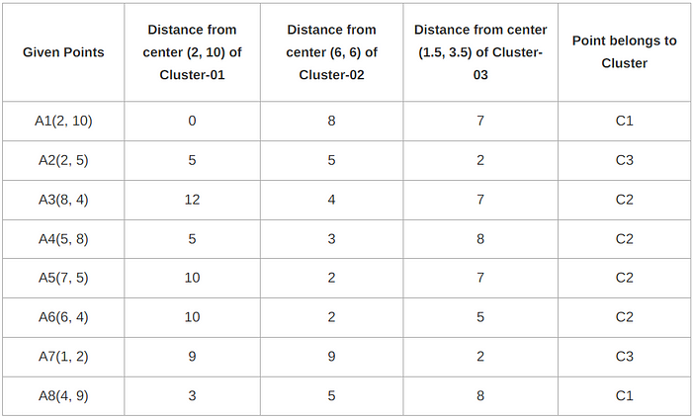

From here, New clusters are:
Cluster-01:
The first cluster contains points-
- A1(2, 10)
- A8(4, 9)
Cluster-02:
The second cluster contains points-
- A3(8, 4)
- A4(5, 8)
- A5(7, 5)
- A6(6, 4)
Cluster-03:
The third cluster contains points-
- A2(2, 5)
- A7(1, 2)
Now,
- We re-compute the new cluster clusters.
- The new cluster center is computed by taking mean of all the points contained in that cluster.
For Cluster-01:
Center of Cluster-01
= ((2 + 4)/2, (10 + 9)/2)
= (3, 9.5)
For Cluster-02:
Center of Cluster-02
= ((8 + 5 + 7 + 6)/4, (4 + 8 + 5 + 4)/4)
= (6.5, 5.25)
For Cluster-03:
Center of Cluster-03
= ((2 + 1)/2, (5 + 2)/2)
= (1.5, 3.5)
This is the completion of Iteration-02.
After the second iteration, the center of the three clusters is:
- C1(3, 9.5)
- C2(6.5, 5.25)
- C3(1.5, 3.5)

How to choose the optimal value of k
The optimal value of k can be chosen using the elbow method. In this method the cost function (variance) is plotted against different values of k. As the value of k increases, the number of clusters decreases and the average distortion also decreases. The optimal value of k is where we see the sharp change in the rate of change of error. For example, in the following illustration, the optimal value of k is 3.

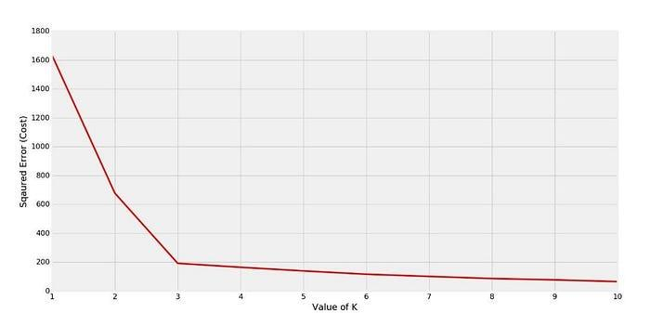

Hierarchical Clustering
Hierarchical clustering is a type of clustering algorithm used in machine learning and data analysis to group similar objects into clusters. It works by iteratively merging the closest pairs of data points or clusters until all data points are in a single cluster or until a desired number of clusters is reached.
There are two types of hierarchical clustering:
- agglomerative
- divisive
agglomerative, which starts with individual data points as clusters and merges them together, and divisive, which starts with all data points in a single cluster and recursively divides them into smaller clusters.
Hierarchical clustering is useful in applications such as image segmentation, social network analysis, and gene expression analysis.
How Hierarchical Clustering Work?
Hierarchical clustering is a clustering algorithm that works by iteratively merging or dividing clusters of data points based on their similarity. The algorithm can be performed in two ways: agglomerative and divisive.
Agglomerative Hierarchical Clustering: Agglomerative hierarchical clustering begins with each data point as a separate cluster and iteratively merges the closest pairs of clusters until all data points belong to a single cluster or a desired number of clusters is reached.

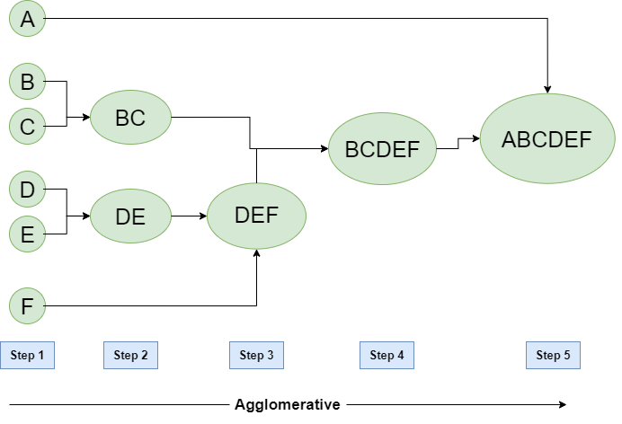
The steps involved in agglomerative hierarchical clustering are:
- Calculate the distance matrix between all pairs of data points.
- Assign each data point to its own cluster.
- Find the pair of clusters with the smallest distance and merge them into a single cluster.
- Update the distance matrix by computing the distances between the new cluster and all other clusters.
- Repeat steps 3 and 4 until all data points belong to a single cluster or the desired number of clusters is reached.
Divisive Hierarchical Clustering: Divisive hierarchical clustering begins with all data points in a single cluster and recursively divides them into smaller clusters until each data point belongs to its own cluster or a desired number of clusters is reached.

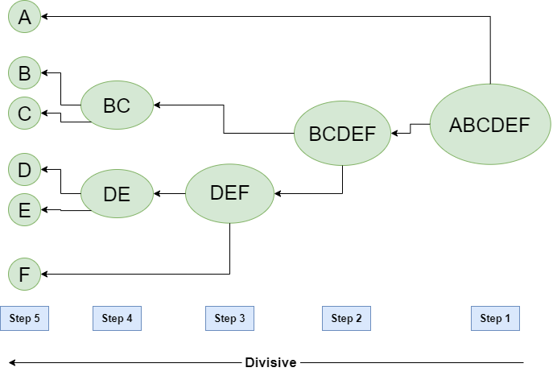
The steps involved in divisive hierarchical clustering are:
- Assign all data points to a single cluster.
- Compute the distance matrix between all pairs of data points.
- Find the data point that is farthest away from all other data points and assign it to a new cluster.
- Divide the remaining data points into two clusters based on their distance from the newly created cluster.
- Repeat step 4 recursively until each data point belongs to its own cluster or the desired number of clusters is reached.
The choice of distance metric and linkage criteria, which define how distances between clusters are computed, can have a significant impact on the clustering results. Common distance metrics include Euclidean distance, Manhattan distance, and cosine distance, while linkage criteria include single linkage, complete linkage, and average linkage.
Linkage criteria in hierarchical clustering
There are several types of linkage criteria used in hierarchical clustering, including:
Single Linkage: In single linkage hierarchical clustering, the distance between two clusters is defined as the shortest distance between two points in each cluster. For example, the distance between clusters “r” and “s” to the left is equal to the length of the arrow between their two closest points.

Complete Linkage: In complete linkage hierarchical clustering, the distance between two clusters is defined as the longest distance between two points in each cluster. For example, the distance between clusters “r” and “s” to the left is equal to the length of the arrow between their two furthest points.
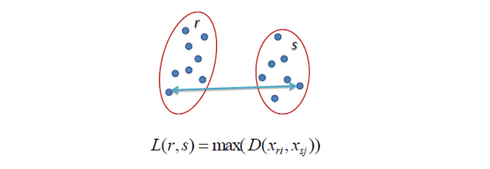
Average Linkage: In average linkage hierarchical clustering, the distance between two clusters is defined as the average distance between each point in one cluster to every point in the other cluster. For example, the distance between clusters “r” and “s” to the left is equal to the average length of each arrow between connecting the points of one cluster to the other.
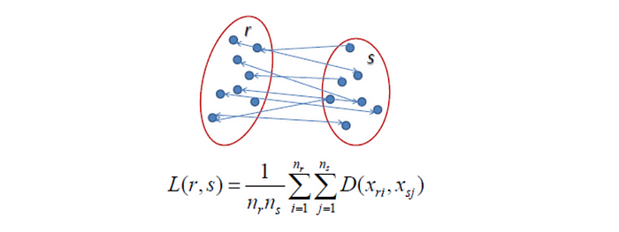

Objective : For the one dimensional data set {7,10,20,28,35}, perform hierarchical clustering and plot the dendogram to visualize it.
Solution : First, let’s the visualize the data.
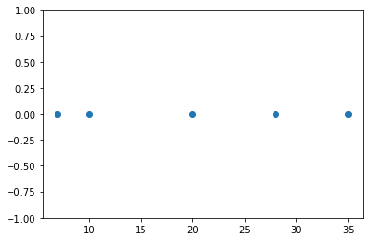
Observing the plot above, we can intuitively conclude that:
- The first two points (7 and 10) are close to each other and should be in the same cluster
- Also, the last two points (28 and 35) are close to each other and should be in the same cluster
- Cluster of the center point (20) is not easy to conclude
Let’s solve the problem by hand using both the types of agglomerative hierarchical clustering :
Single Linkage : In single link hierarchical clustering, we merge in each step the two clusters, whose two closest members have the smallest distance.

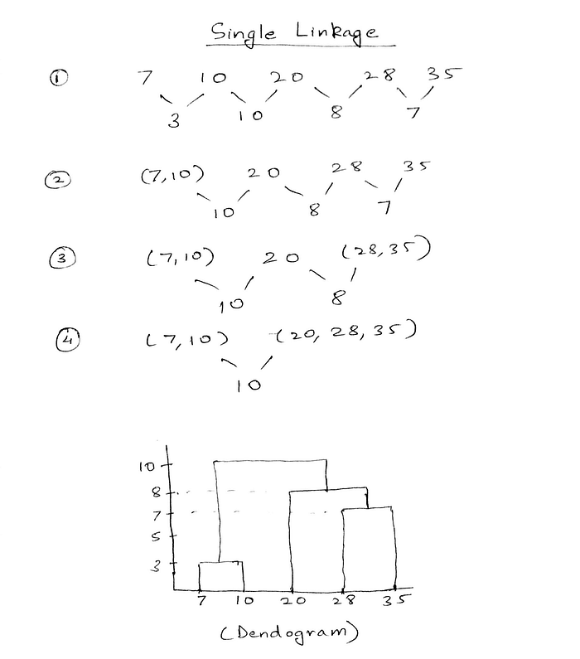
Using single linkage two clusters are formed :
Cluster 1 : (7,10)
Cluster 2 : (20,28,35)
Example of Hierarchical Clustering
Clustering the following 7 data points.

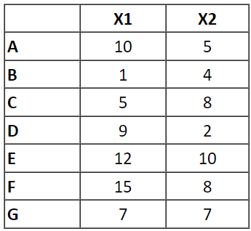
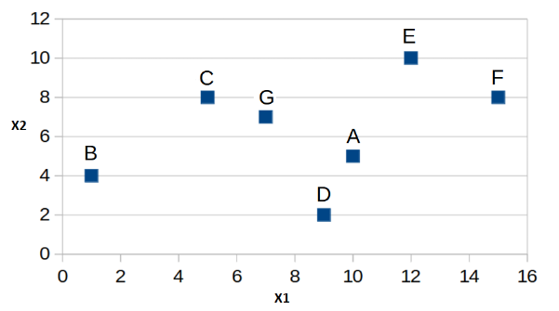
The vertical axis represents the distance between the clusters, while the horizontal axis represents the data points or clusters being merged or divided.
The steps involved in an Example of hierarchical clustering are:
Step 1: Calculate distances between all data points using the Euclidean distance function. The shortest distance is between data points C and G.
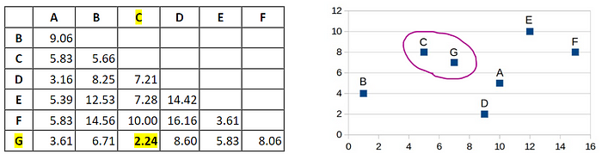
Step 2: We use “Average Linkage” to measure the distance between the “C, G” cluster and other data points.
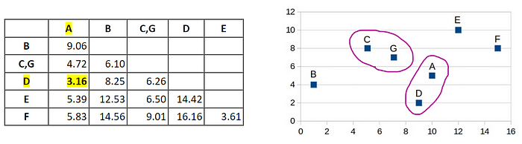
Step 3: Continue with Step 2.
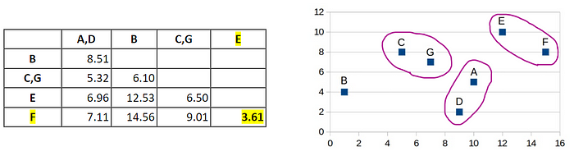
Step 4: Continue with Step 3.
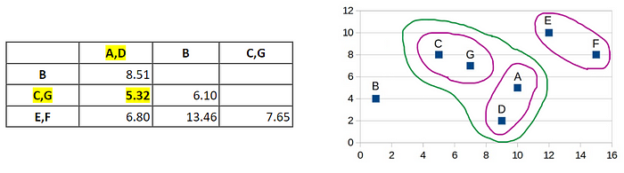
Step 5: Continue with Step 4.
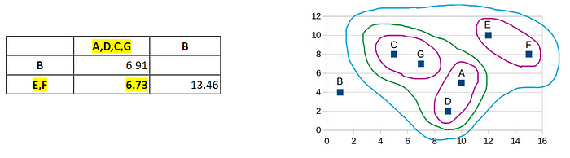
Step 6: Continue with Step 5.
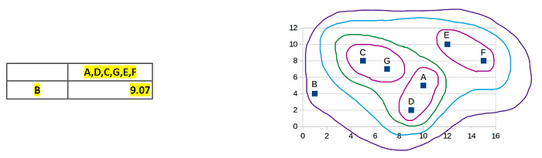
A diagram to show the results of hierarchical clustering applied to a dataset with 10 data points.
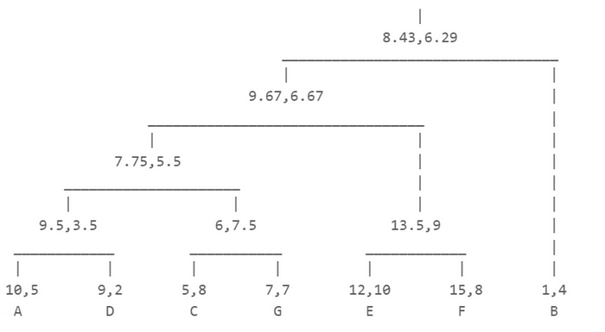

Feature Selection for Clustering Algorithms
Aside from choosing only features that you will have available when the model is deployed to production, you should only pick features that you want your clusters to be differentiated by, either for a business objective or for an analytical reason.
Before this you should perform a correlation analysis: features that you think might not have any kind of relationship might actually be correlated, so you should avoid using one of them, keeping the one that is more interpretable and easier to obtain.
Imagine you have a dataset of customers of a bank with gender, age, location, transactions, number of products, account balance, etc…
If you were planning to execute a clustering algorithm to divide the whole client universe into different segments in order to target each of them with different marketing strategies, but wanted to have a homogeneous strategy across all the territories where the bank operates, including the ‘location’ variable in the clustering would make no sense, as our clustering model would use the location variable to separe the clusters and that differentiation wouldn't actually provide any business value.
When you’ve selected the correct and most relevant features for your model and engineered them, you should stop to consider a fundamental step of any clustering project: Feature Scaling.
Feature Scaling
Feature scaling is a family of statistical techniques that scale the features of our data so that they all have a similar range. You will best understand if we see a quick example:
Imagine we have data about the amount of money that our bank clients have, that goes in the 0–1.000.000$, and information about their age, that is in the 18–100 range.
If we apply a feature scaling technique to this data set, it would scale both features so that they are in the same range, for example, 0–1 or -1 to 1.
Why is this important for Clustering Models?
It turns out most of these models operate using some sort of distance metric to build the clusters, so if the features of our data set have very different orders of magnitude those with the highest range will have a higher weight in the calculation of these distance metrics, and therefore capitalise most of the variance and the differences in between our clusters.
Consider the following figure, where we’ve applied a K-means clustering model (one of the most basic but widely used techniques) to a data set containing weight in kilograms and height in meters from different individuals.
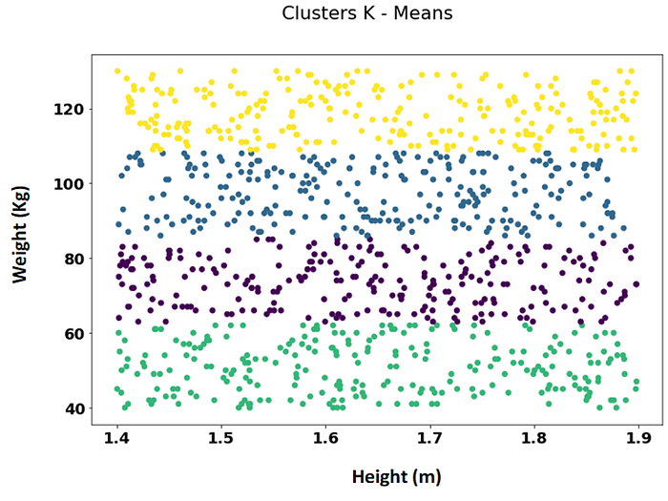
K-means clustering to a Data Set containing Weight and Height of individuals without feature scaling: Our Height variable is being ignored by the model
As the range of Weight (40–130kg) is way bigger than the range of the Height variable (1.4 to 2m), our clusters (illustrated by the different colours) contain individuals of all heights but different weight ranges: from 40 to around 60, from 60 to 82, and so on…
Our height variable is being ignored by the clustering algorithm.
Now, these groups are not what we wanted: we want our model to consider both variables when making the clusters.
Feature scaling is the solution to this problem. In the following figure we can see what happens when we scale the data using a standardization technique and then apply exactly the same K-means clustering model as before
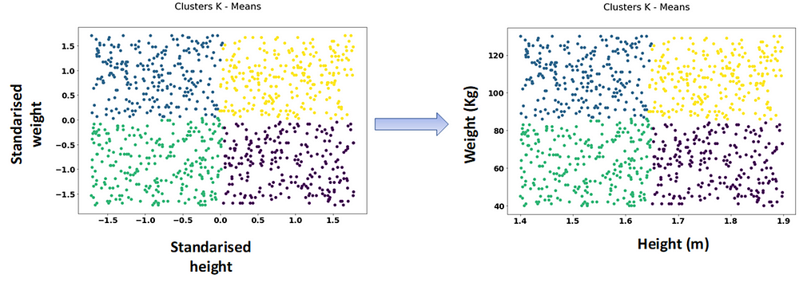
Clusters obtained after scaling the features of our data and taking the cluster labels back to the original data set
On the left, we have the standarised features and the corresponding clusters. If we take these clusters to the original, un-scaled data set we get the clusters on the right: 4 groups of different weights and heights.
Dimensionality reduction 🧊
Dimensonality reduction describes a set of techniques that have the goal of taking our original (or scaled) N-dimensional data and compressing it into less dimensions (N-k dimensions) while conserving the most possible information from the original data set.
The most well-known dimensionality technique is Principal Component Analysis or PCA, and it is a common step in most unsupervised machine learning pipelines before the modelling.
Why?
As we increase the dimensions of our data, the average distance in between two points of our data set is increased. It’s like the metric used to calculate the distance gets blurred and looses its meaning.
This can be seen in the following figure: as we increase the number of dimensions from 1 to 3 the points of our data set get closer and closer to the edges of our N-dimensional space and the average distance between two points increases.
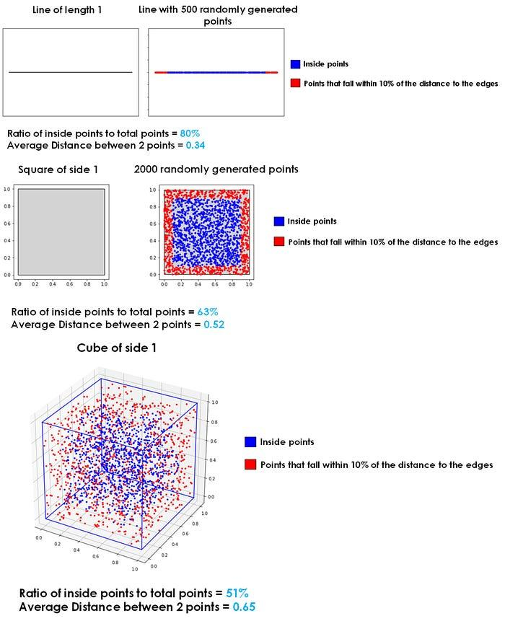
What happens to X randomly distributed points when we increase the dimensions of our data
Because of this, for our clustering model to work best we should aim at having a reduced set of features.
We can achieve this through feature selection process, where very few features are chosen, or, if we want our model to operate on a high number of relevant features, applying a dimensionality reduction technique like PCA before the modelling.
Once feature selection, scaling and dimensionality reduction have been done, we can proceed to the modelling part of the clustering pipeline.

